**SPECIAL RELATIVITY AND THE STANDARD MODEL TEST – 2018**

**NAME_______________________**

*Answers to 3 Significant Figures*  (60 Marks, 60 Minutes + 5 min reading)

**QUESTIONS 1-6 MULTIPLE CHOICE** – Circle letter of correct answer *(1 Mark each)*

1. If you were to travel at a speed close to the speed of light, you would notice that your own

a) mass changes

b) pulse decreases

c) dimensions change

d) all of the above

e) none of the above

2. Which of these quark combinations is a possible particle?

a)

b)

c)

d)

e) none of the above

3. Which of the following is an example of an inertial reference frame?

a) a rocket during take off

b) a train travelling at constant velocity

c) a car turning a corner at constant speed

d) a lift slowing down as it approaches the ground

e) none of the above

4. Which of the following is a correct statement about the Michelson-Morley experiment?

a) it proved the existence of the luminiferous aether

b) it compared the speeds of light rays travelling along parallel paths

c) it was invalid because the equipment was not sufficiently sensitive

d) it was unable to detect the movement of the Earth through the luminiferous aether

e) both c) and d)

5. The length of a spaceship is measured by an observer to be 3.57m as the spaceship passes with a velocity of 0.7c. At what velocity would the spaceship be moving relative to the observer if its measured length was 2.5m?

a) 0.490c

b) 0.707c

c) 0.714c

d) 0.749c

e) 0.866c

6. Which of the following affects the speed of light?

a) nothing affects the speed of light – it is always constant

b) the speed of the observer

c) the speed of the transmitter

d) the medium the light is travelling through

e) the frequency of the light

**Question 7** *(3 Marks)*  WACE 2015

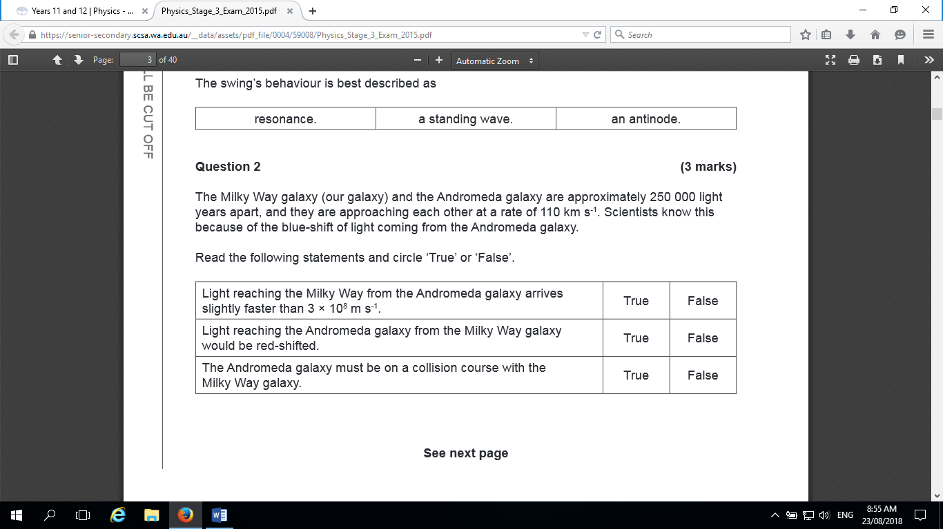

**Question 8** *(4 Marks)* WATP 2013

Galaxy NGC 3351 is in the constellation of Leo. It is a distance of 11.7 megaparsecs from Earth. One parsec equals 3.26 light-years. A light-year is the distance travelled by light in one year. Calculate the distance to NGC 3351 in kilometres.

(4)

Distance (ly) = 11.7 106 3.26 = 38 142 000 ly ✓

1 ly in metres = s x t = 3 x 108 x 365 x 24 x 60 x 60

1 ly = 9.4608 x 1015 m ✓

Distance to NGC 3351 = distance (ly) x 9.4608 x 1015

Distance to NGC 3351 = 38 142 000 x 9.4608 x 1015

Distance to NGC 3351 = 3.61 x 1023 m ✓

Distance to NGC 3351 = 3.61 x 1020 km ✓

**Question 9** *(4 Marks)*

The line emission spectra observed from elements in distant stars can be compared to line emission spectra from the same elements in a laboratory. Explain what differences between the two spectra are likely to be seen and from this, what information can be deduced about the stars that can be applied to Hubble’s Law.

(4)

The spectral lines from the distant star will have the same pattern but the wavelength will be shifted to be longer for each line. (Redshift)✓ This indicates that the source of the waves (the star) is moving away relative to the Earth. ✓ From the amount of redshift the recessional speed of the source can be determined. ✓ Hubble’s Law relates the recessional speed to the distance to the source. ✓

OR – this indicates that the universe is expanding, OR indicates that Universe originated from Big Bang. Any 4 well linked points.

**Question 10** *(4 Marks)*  **WACE 2013**

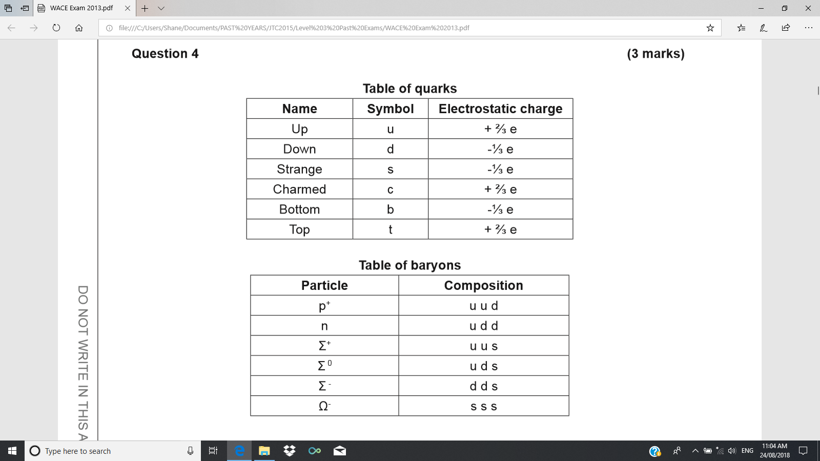

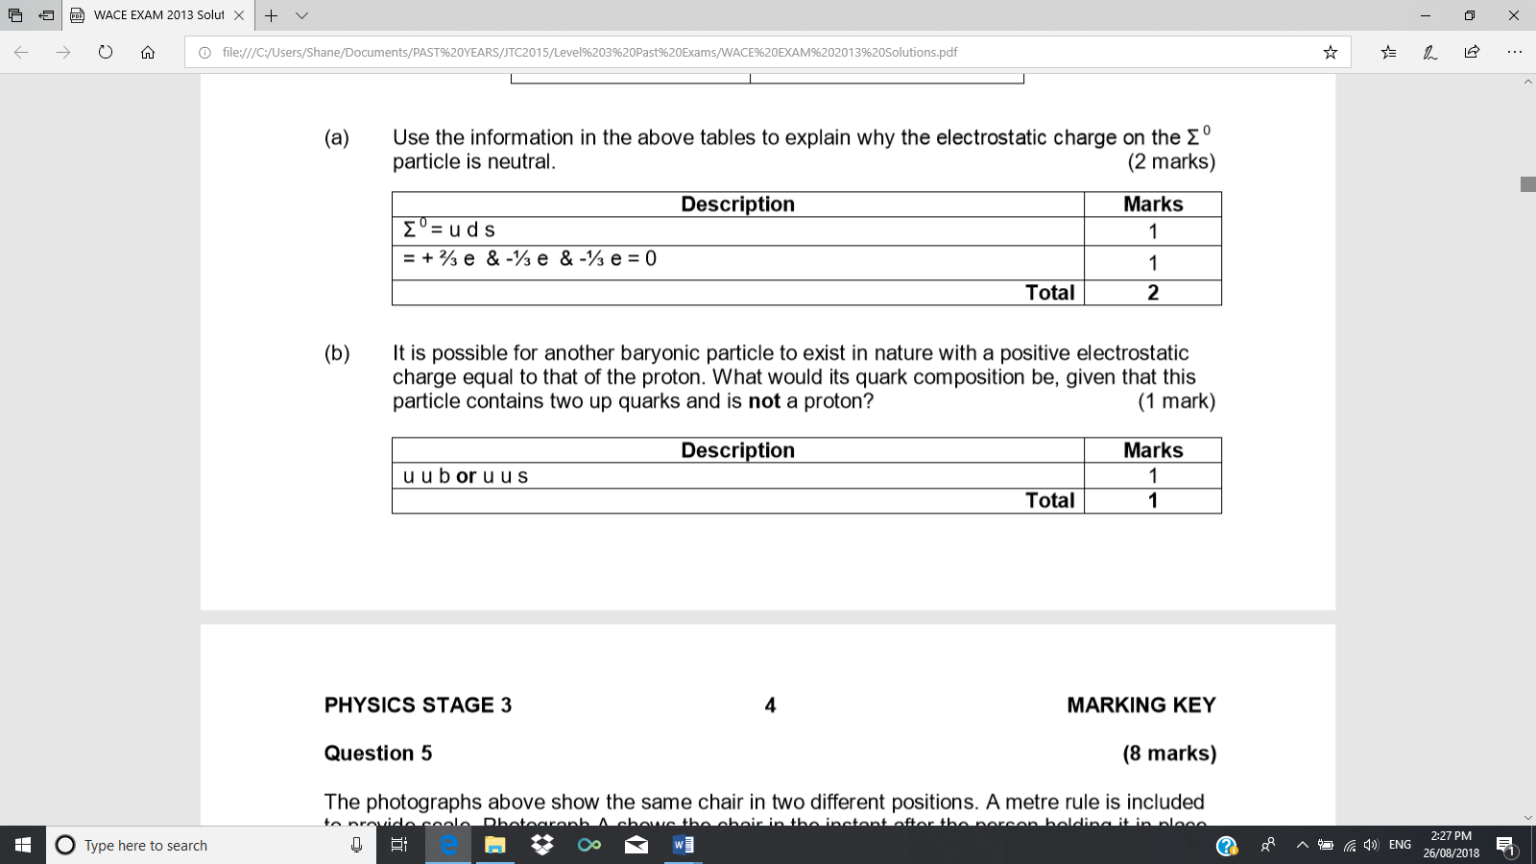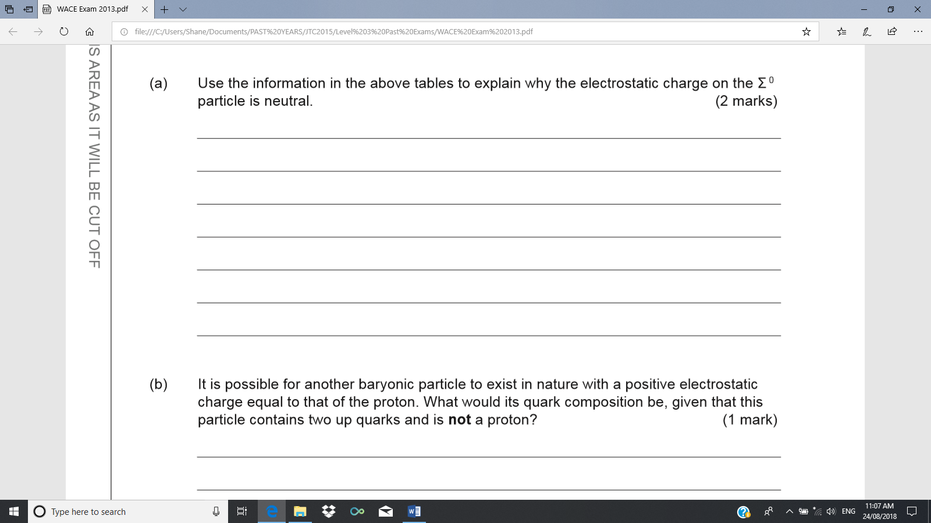





(c) What is the charge on a meson consisting of an up quark and an anti-matter down quark? *(1 mark)*

+1 ✓

**Question 11** *(5 Marks)*

a) The Higgs-boson has a mass between 125 GeVc-2 and 126 GeVc-2. Express this in kilograms with an absolute error margin.  *(4 Marks)*

Mass in kg = ✓✓

kg ✓✓

kg

b) Other bosons are force mediators. What is the role of the Higgs-boson? *(1 Mark)*

Gives mass to some other particles ✓

**Question 12** *(10 Marks)*

Identify the missing particle in each equation, choosing from these:

, , , , , ,

*(Note- there is only one correct answer for each equation, but you may give the same answer more than once)*

1. ✓✓
2. ✓✓
3. + _ _______ ✓✓

1. ✓✓
2. ✓✓

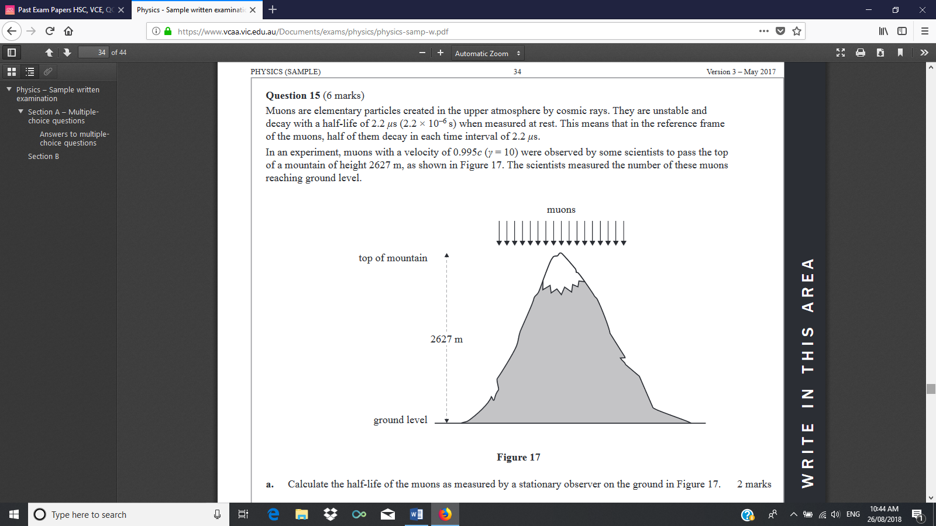**Question 13** *(10 Marks)*

Muons are elementary particles created in the upper atmosphere by cosmic rays. They are un stable and decay with a half-life of 2.2 when measured at rest.

In an experiment, muons with a velocity of 0.995c were observed by some scientists to pass the top of a mountain of height 2627 m, as shown in the diagram.

1. Calculate the half-life of the muons as measured by a stationary observer on the ground.

*(3 Marks)*

✓✓

✓

1. From the reference frame of the muons, what is the height of the mountain?

*(3 Marks)*

✓✓

✓

1. How long does it take the muons to hit the ground from when they pass the top of the mountain
2. From the point of view of the muon

*(2 Marks)*

✓

✓

1. From the point of view of the observer on the ground

*(2 Marks)*

✓

✓

**Question 14***(8 Marks)***WACE 2015**

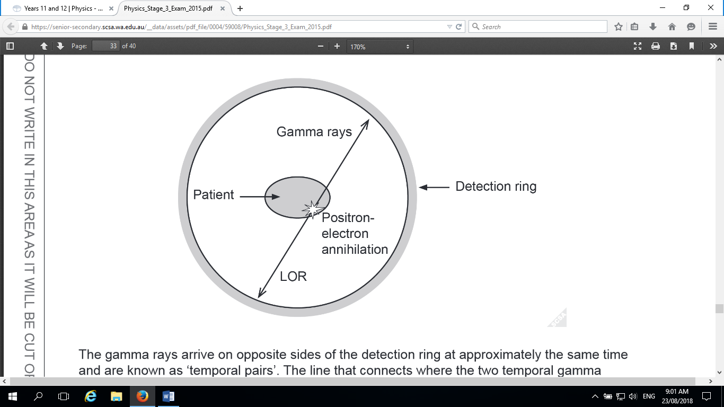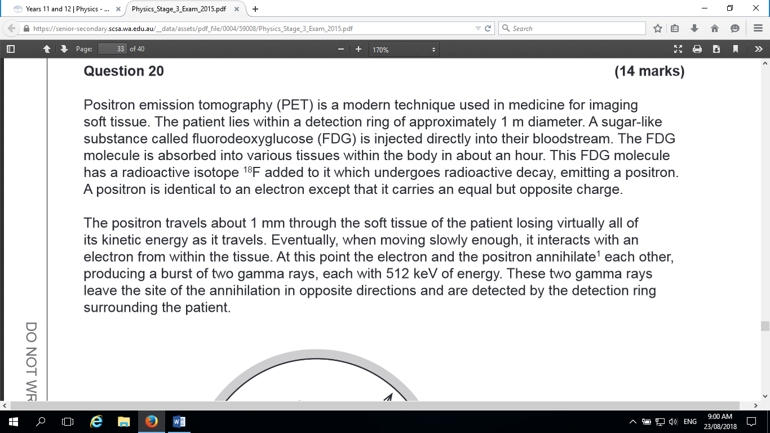

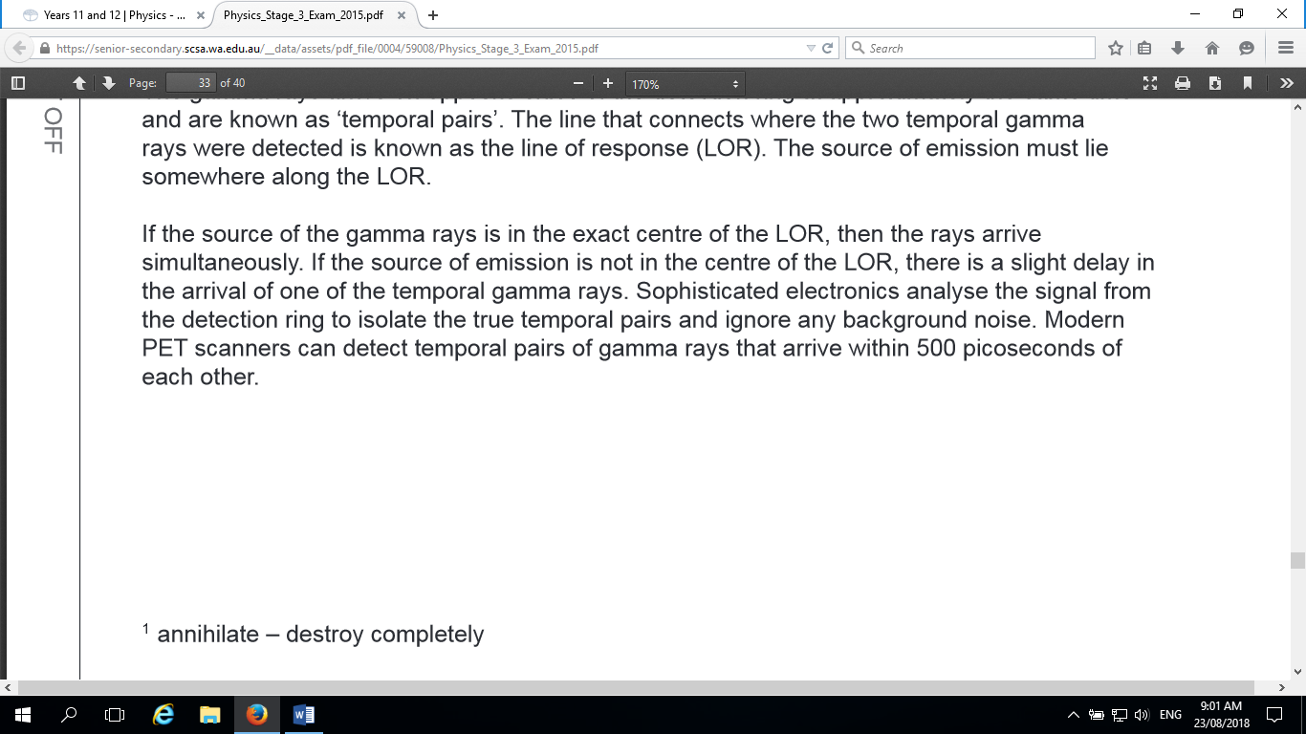

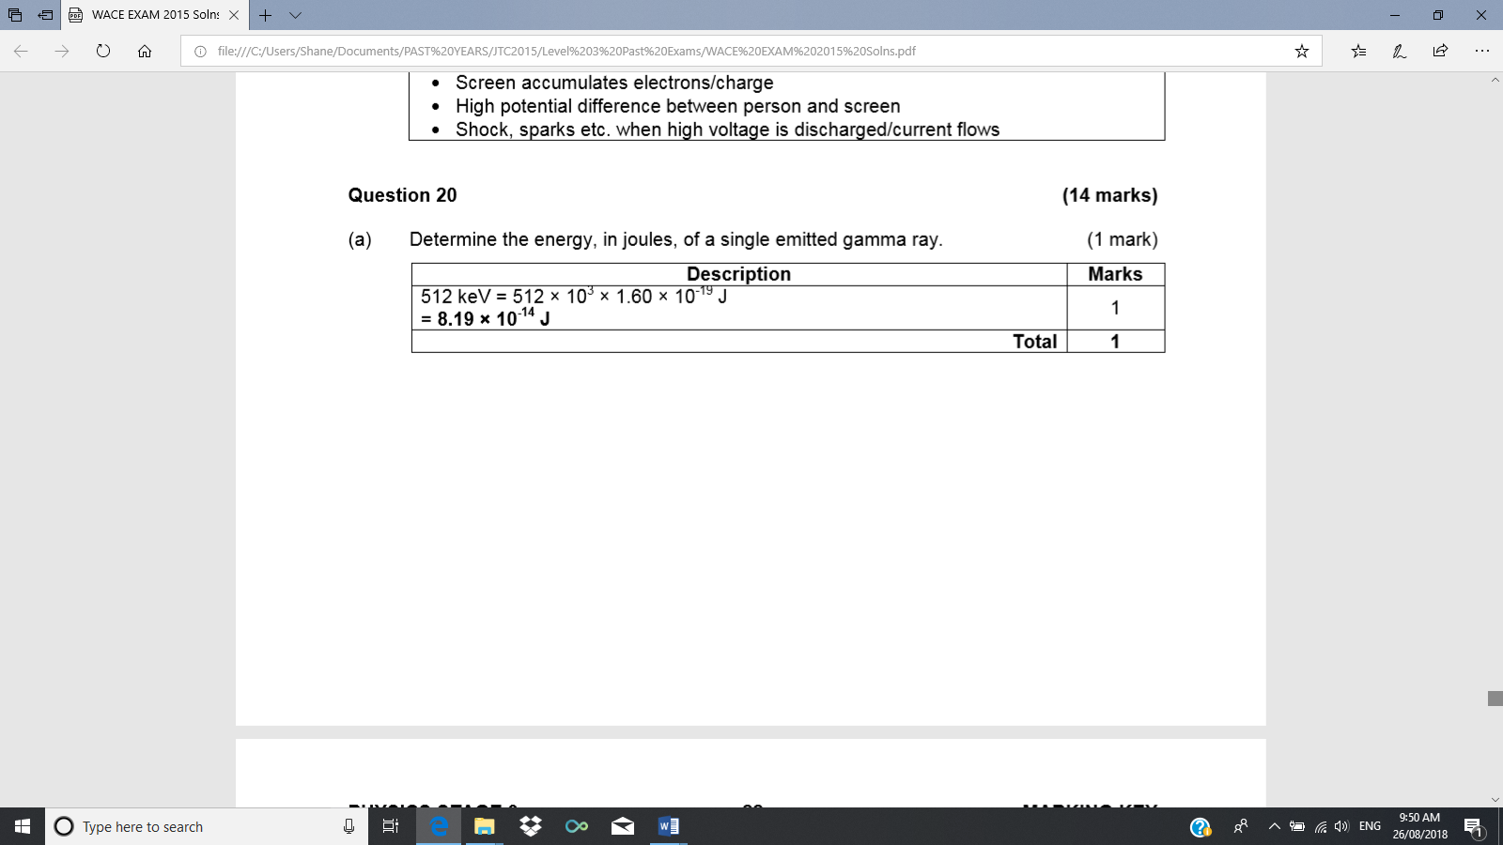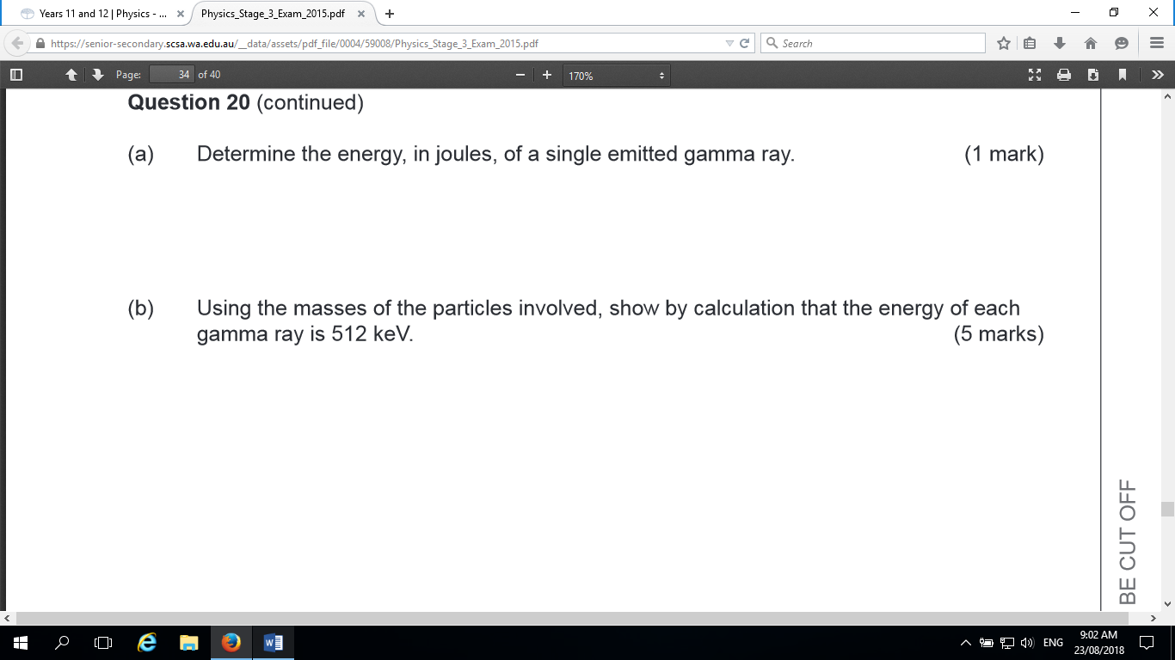

*(3 Marks)*

✓

= 8.199 J ✓

✓

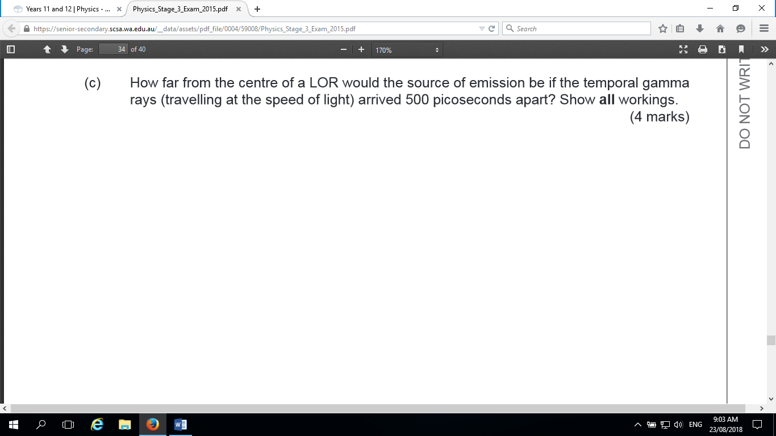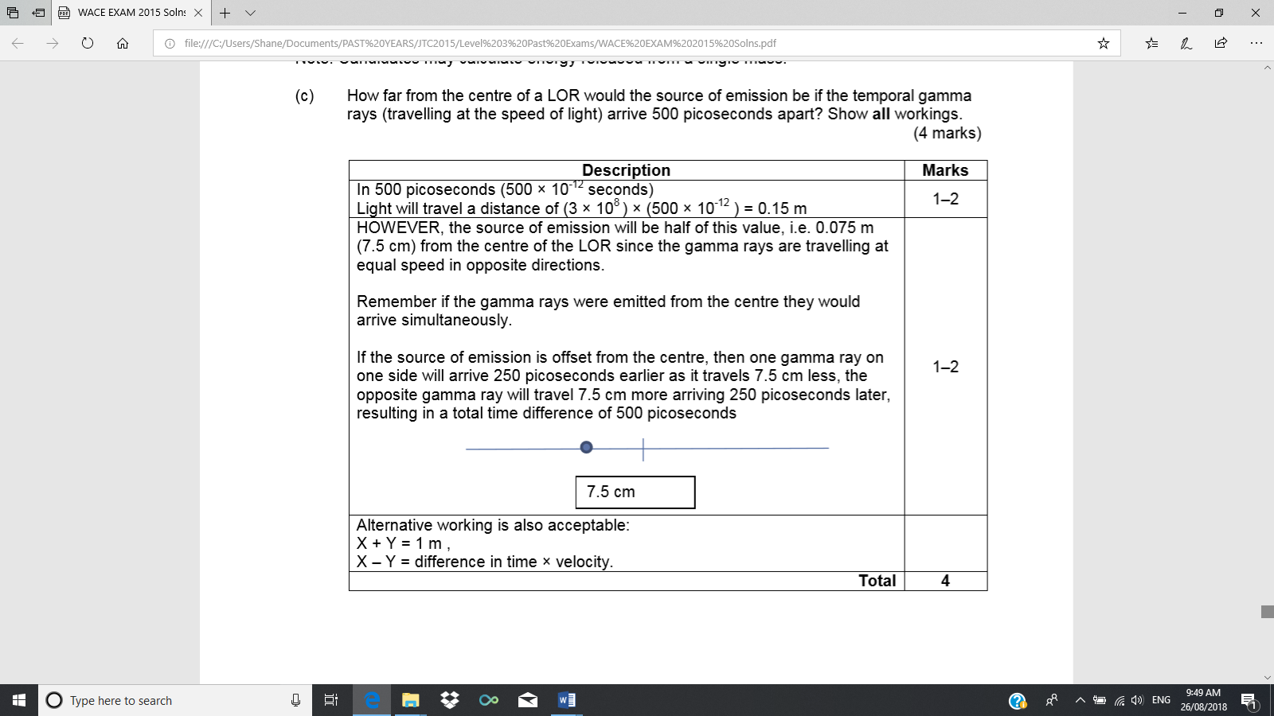

**Question 15** *(4 Marks)*

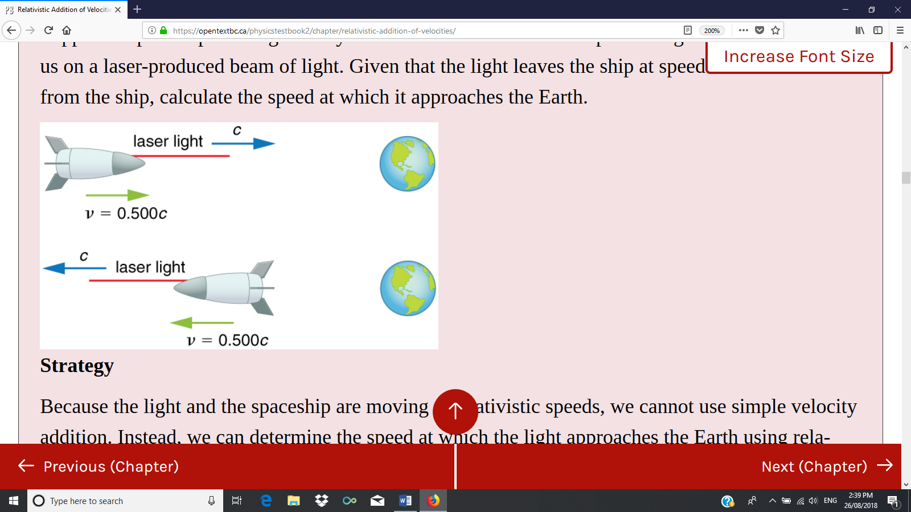A spaceship travelling at 0.5c, sends a signal coded in laser light to Earth.

Use the appropriate relativistic velocity addition equation to show that the speed of the signal as observed from Earth will in fact be c, the speed of light.

✓

✓

✓

✓

**Question 16** *(2 Marks)*

0.85 c

Light B

Light A

Stationery observer

Astronaut

An astronaut flies past a stationary observer at a constant 85% of the speed of light. His spacecraft has light A at the front and light B at the rear. The astronaut sees the two lights A and B illuminate simultaneously. From the frame of reference of the stationary observer explain the order of the lights going on.

*(2 Marks)*

*B then A.* ✓

To the observer the distances to both lights are the same, whereas the astronaut effectively shortens their distance to A by moving towards it. ✓